***Final team Project Group15***

**Queries Description and sample queries**

1.1 Student Discipline from School Administrator perspective:

For each facility, how many students violate the discipline per year?

use Schools_K12_DW

select df.FacilityName,count(fd.StudentID) as DisciplineStudentNumber,

year(fd.EventDate) AS Year

from dbo.factDiscipline as fd join

dbo.dimFacility as df

on fd.EventFacilityID= df.FacilityID

group by df.FacilityName,year(fd.EventDate)

order by year(fd.EventDate),DisciplineStudentNumber DESC

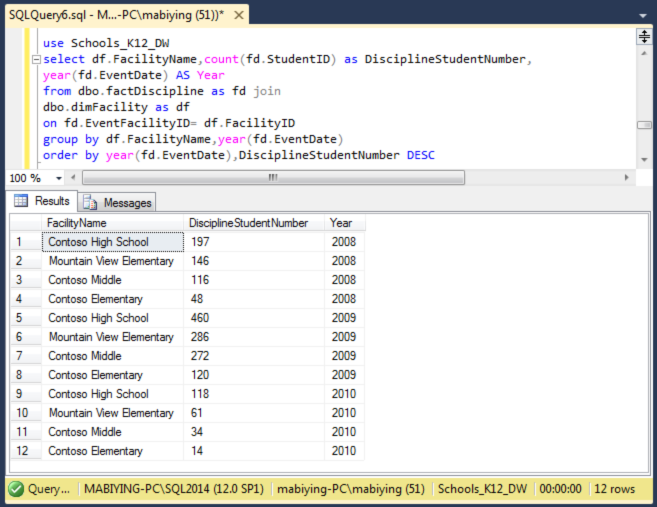

1.2 Student Discipline from parents perspective:

Rank the top 3 common Discipline Events

use Schools_K12_DW

select dde.DisciplineEventCode, dde.DisciplineEventDesc, count(ds.StudentID) as DisciplineStudentNumber,

DENSE_RANK() OVER(ORDER BY count(ds.StudentID) DESC) AS [DisciplineReason_RANK]

from dbo.factDiscipline as fd join

dbo.dimDisciplineEventCode as dde

on dde.DisciplineEventCodeID=fd.DisciplineEventCodeID join

dbo.dimStudent as ds

on ds.StudentID = fd.DisciplineEventCodeID

group by dde.DisciplineEventCode, dde.DisciplineEventDesc

order by DisciplineStudentNumber DESC

OFFSET 0 ROWS FETCH NEXT 3 ROWS ONLY;

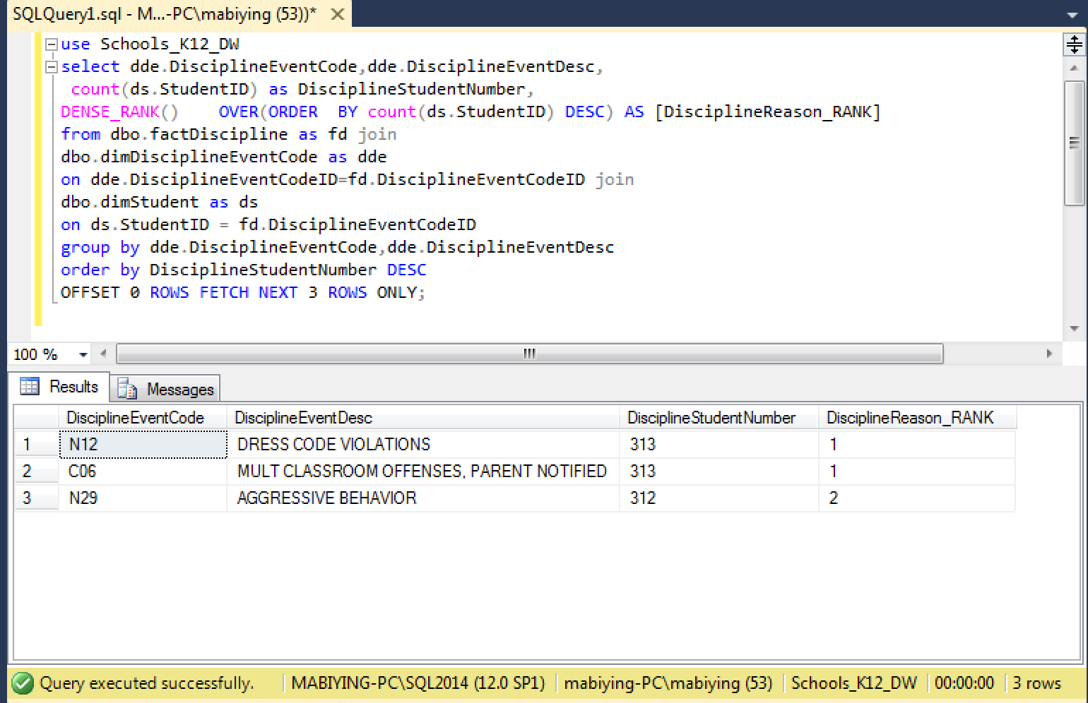

1.3 Student Discipline from teachers perspective:

For each discipline behaviors, compare the total number of female students and male students

select dde.DisciplineEventCodeID,dde.DisciplineEventDesc,c.F,c.M,c.[M>F]

from dbo.dimDisciplineEventCode as dde

left join

((select b.DisciplineEventCodeID,

sum(case when b.Gender= 'F' then 1 else 0 end) as F,

sum(case when b.Gender= 'M' then 1 else 0 end) as M,

Convert(varchar, Case When sum(case when b.Gender= 'M' then 1 else 0 end) >

sum(case when b.Gender= 'F' then 1 else 0 end) Then 1 Else 0 End) As 'M>F'

from (

SELECT distinct fd.StudentID, ds.Gender, fd.DisciplineEventCodeID

from dbo.dimStudent as ds inner join

dbo.factDiscipline as fd on

ds.StudentID = fd.StudentID

)b group by b.DisciplineEventCodeID)) as c

on dde.DisciplineEventCodeID = c.DisciplineEventCodeID

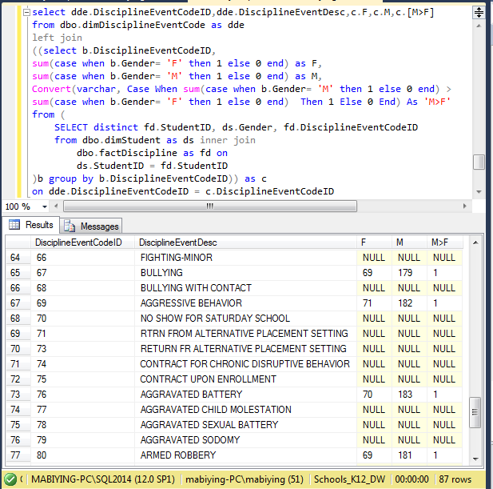

2.1 Student Absences from School Administrator perspective:

How many absent students are there in each facility?

use Schools_K12_DW

SELECT df.FacilityName , count(dd.StudentID) as AbsentStudentNumber

FROM

dbo.factAbsence fb join

dbo.dimStudent dd on

fb.StudentID = dd.StudentID join

dbo.dimFacility df on

df.FacilityID = dd.FacilityID

Group by df.FacilityName

order by AbsentStudentNumber DESC

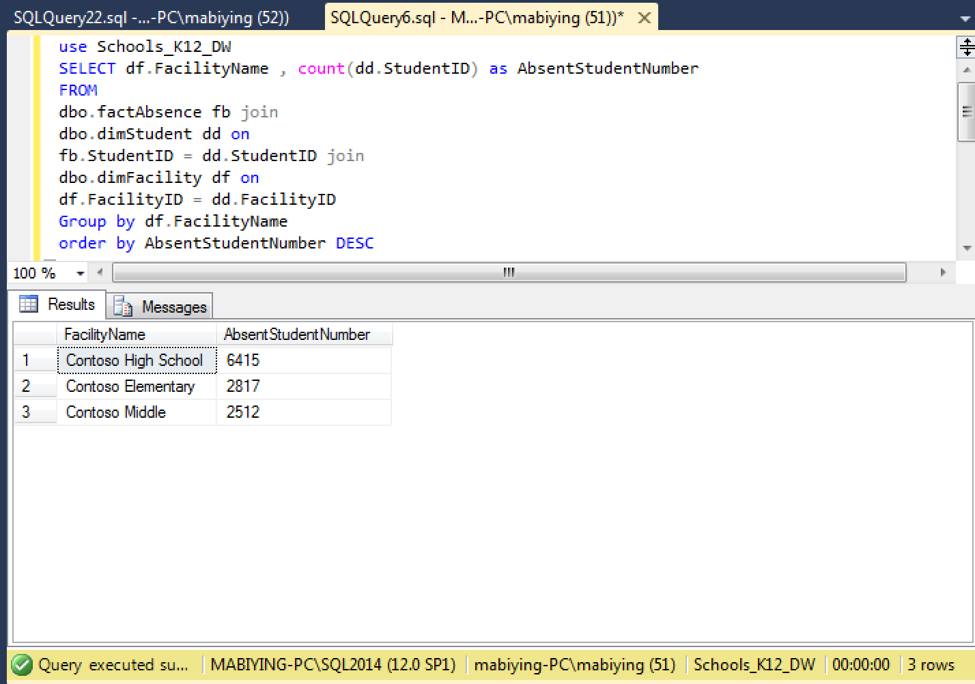

2.2 Student Absences from teachers perspective:

unexcused absence reason percentage of the total absences

select a.Number_of_Y, a.Number_of_N,

a.Total_Number,

convert(varchar,

round(cast(a.Number_of_Y as float)/cast(a.Total_Number as float)*100,2))+'%' as Percentage

from (

select sum(case when da.Unexcused = 'Y' then 1 else 0 end) as Number_of_Y,

sum(case when da.Unexcused = 'N' then 1 else 0 end) as Number_of_N,

count(fa.StudentID) as Total_Number

from dbo.factAbsence as fa join

dbo.dimAbsenceCode da on

fa.AbsenceCodeID = da.AbsenceCodeID

)a

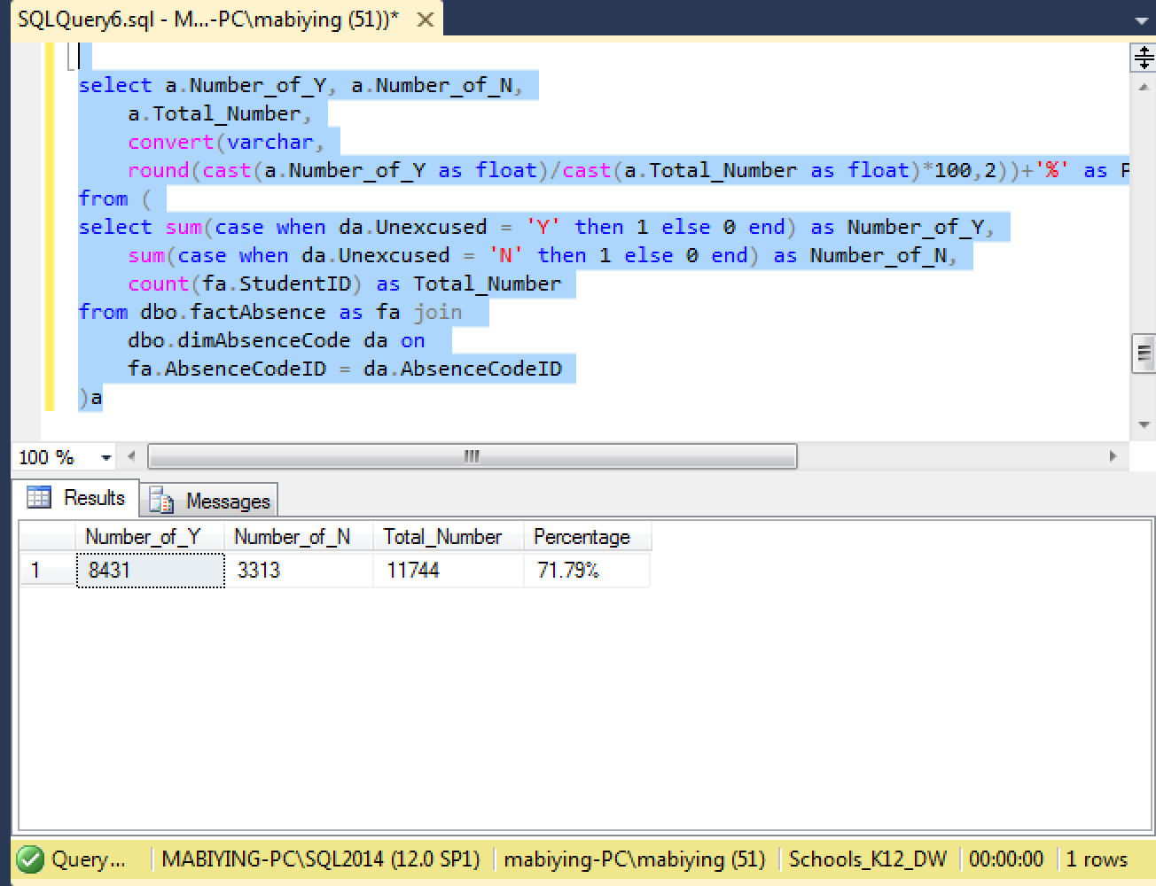

2.3 Student Absences from parents perspective:

Rank the reason why students are absent

use Schools_K12_DW

select da.AbsenceCodeDesc, count(ds.StudentID) as AbsentStudentNumber,DENSE_RANK() OVER(ORDER BY count(ds.StudentID) DESC) AS [AbsenceReason_RANK]

from dbo.factAbsence as fa join

dbo.dimAbsenceCode as da

on da.AbsenceCodeID=fa.AbsenceCodeID join

dbo.dimStudent as ds

on ds.StudentID = fa.StudentID

group by da.AbsenceCodeDesc

order by AbsentStudentNumber DESC

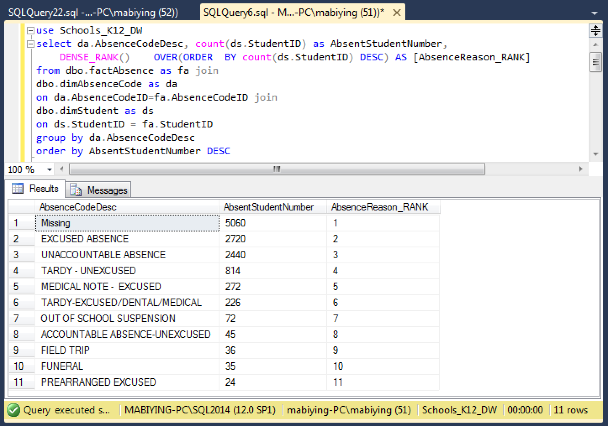

3.1 Academic performance from School Administrator perspective:

For each facility, list average raw score and scaled score for every subject

select df.FacilityName,fsd.SubjectID,

AVG(fsd.ScaledScore) as ScaledScore,

AVG(fsd.RawScore) as RawScore

from dbo.factStandardizedTestScore as fsd

join dbo.dimStudent as ds on

ds.StudentID=fsd.studentID join

dbo.dimFacility as df on

ds.FacilityID = df.FacilityID

group by df.FacilityName,fsd.SubjectID

order by df.FacilityName

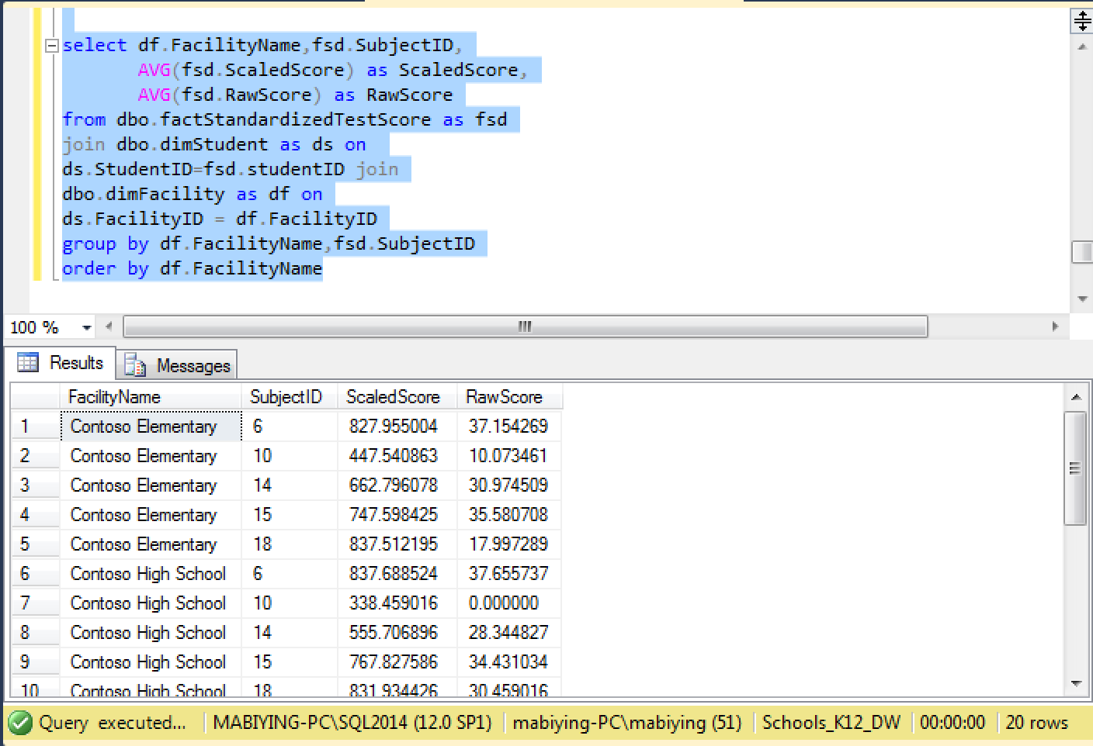

3.2 Academic performance from teachers perspective:

Average numeric grade of students for each course

select dc.CourseID,dc.CourseTitle,avg(fscg.NumericGrade) as AverageScore

from dbo.factStudentCourse as fsc join

dbo.dimCourse as dc on

fsc.CourseID = dc.CourseID join

dbo.factStudentCourseGrade as fscg

on fscg.StudentCourseID = fsc.StudentCourseID

group by dc.CourseID,dc.CourseTitle

order by avg(fscg.NumericGrade) desc

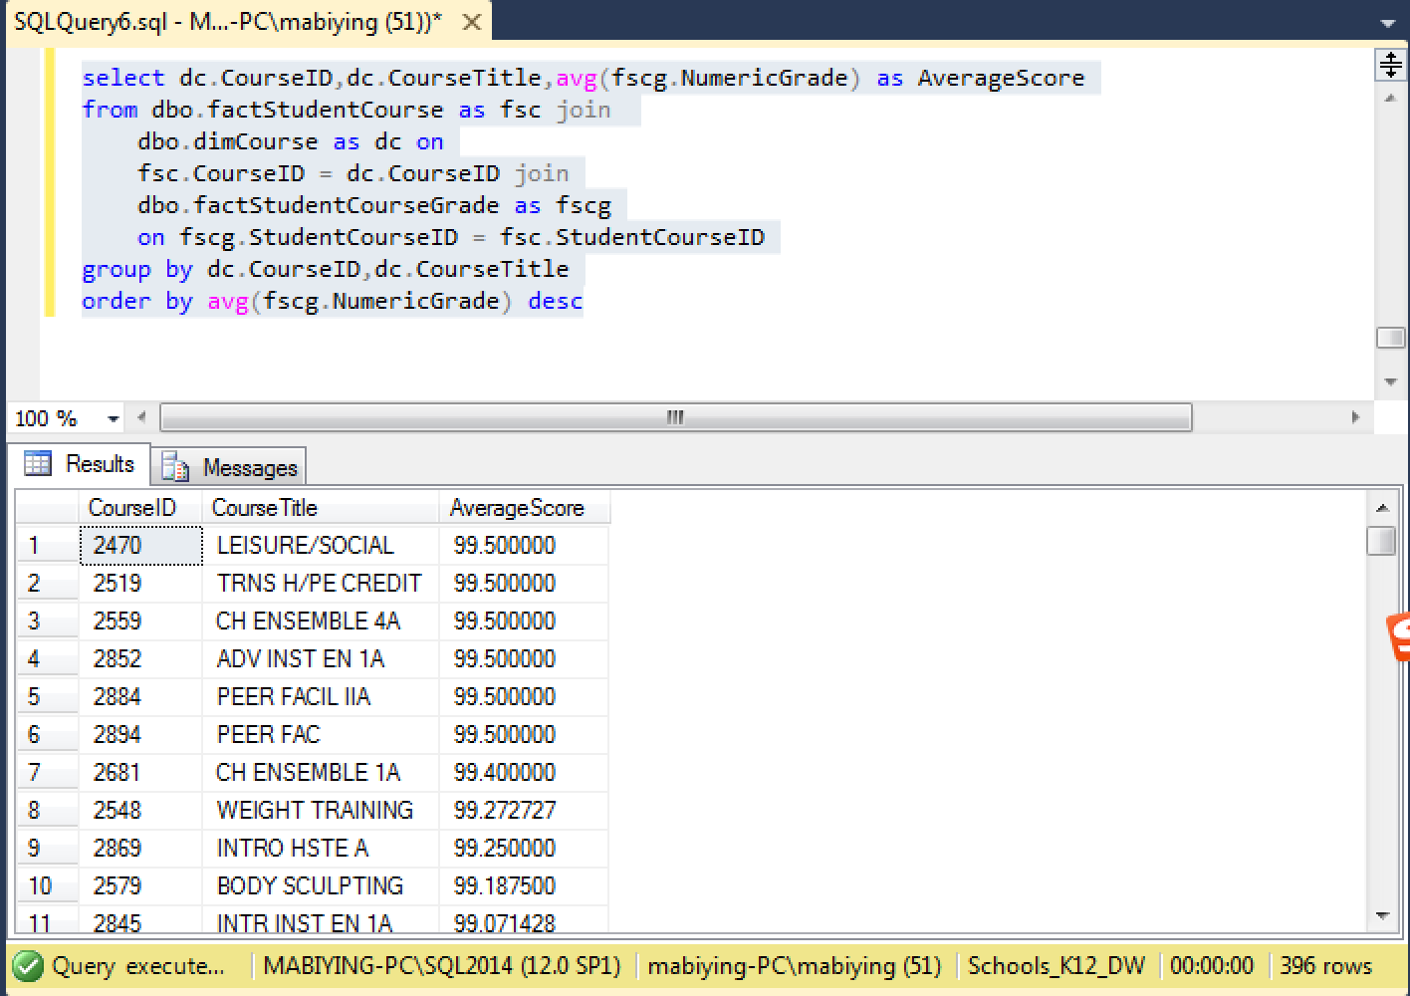

3.3 Academic performance from parents perspective:

Rank student average course score by course

select dc.CourseTitle,ds.StudentID,ds.StudentName,avg(fscg.NumericGrade) as AverageScore,

RANK() over( PARTITION BY dc.CourseTitle order by avg(fscg.NumericGrade) desc) as RankByScore

from dbo.factStudentCourse as fsc join

dbo.dimstudent as ds on

fsc.StudentID = ds.StudentID join

dbo.dimCourse dc on

fsc.CourseID = dc.CourseID join

dbo.factStudentCourseGrade as fscg on

fsc.StudentCourseID = fscg.StudentCourseID

group by ds.StudentID,ds.StudentName, dc.CourseTitle

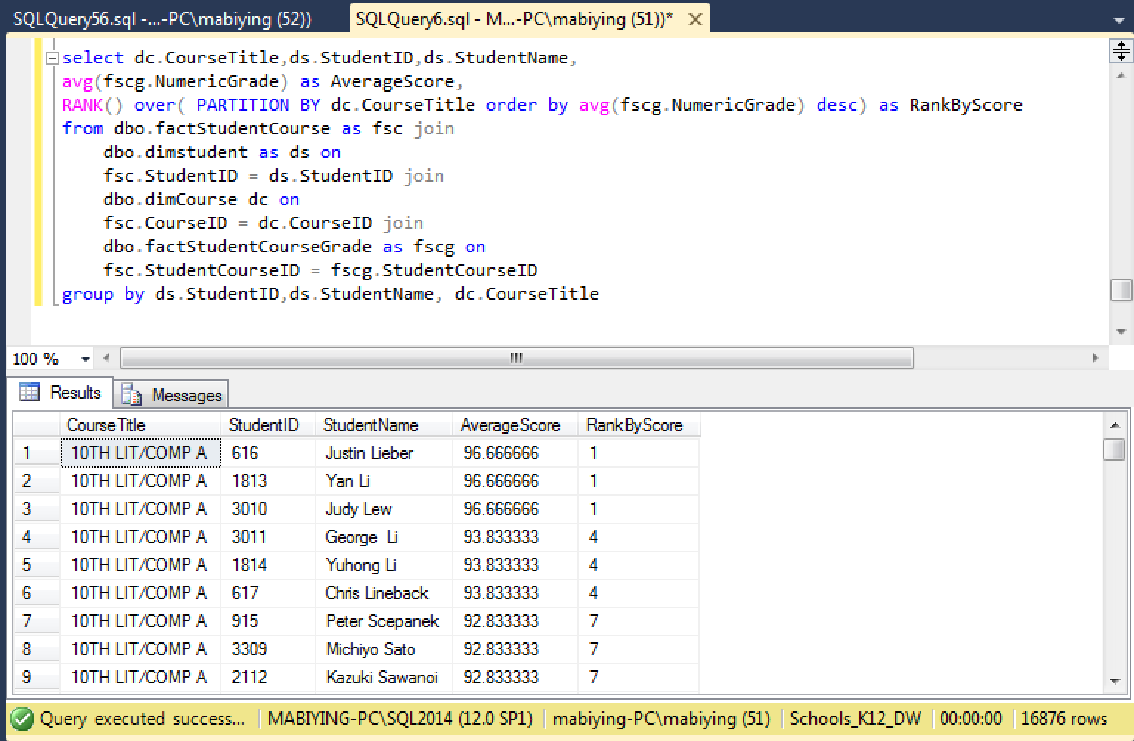

4.1 Special Programs from School Administrator perspective:

How many Special Programs are there in every facility per year?

use Schools_K12_DW

select df.FacilityName,count(fsp.SpecialProgramID) as SpecialProgramNumber,

year(fsp.EntryDate) AS Year

from dbo.factSpecialProgram as fsp join

dbo.dimStudent as dS

on fSP.StudentID= dS.StudentID JOIN

dbo.dimFacility as df on

df.FacilityID = ds.FacilityID

group by df.FacilityName,year(fsp.EntryDate)

order by year(fsp.EntryDate),SpecialProgramNumber DESC

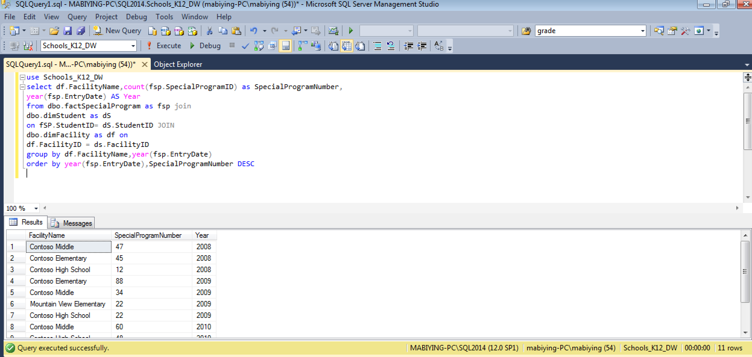

4.2 Special Programs from teacher perspective:

How many Special Programs are there in every program?

use Schools_K12_DW

select fsp.ProgramID,dsp.ProgramCode,count(fsp.SpecialProgramID) AS SpecialProgramNumber

from dbo.factSpecialProgram as fsp join

dbo.dimSpecialProgram as dsp on

dsp.ProgramID = fsp.ProgramID

group by fsp.ProgramID,dsp.ProgramCode

order by SpecialProgramNumber DEsc

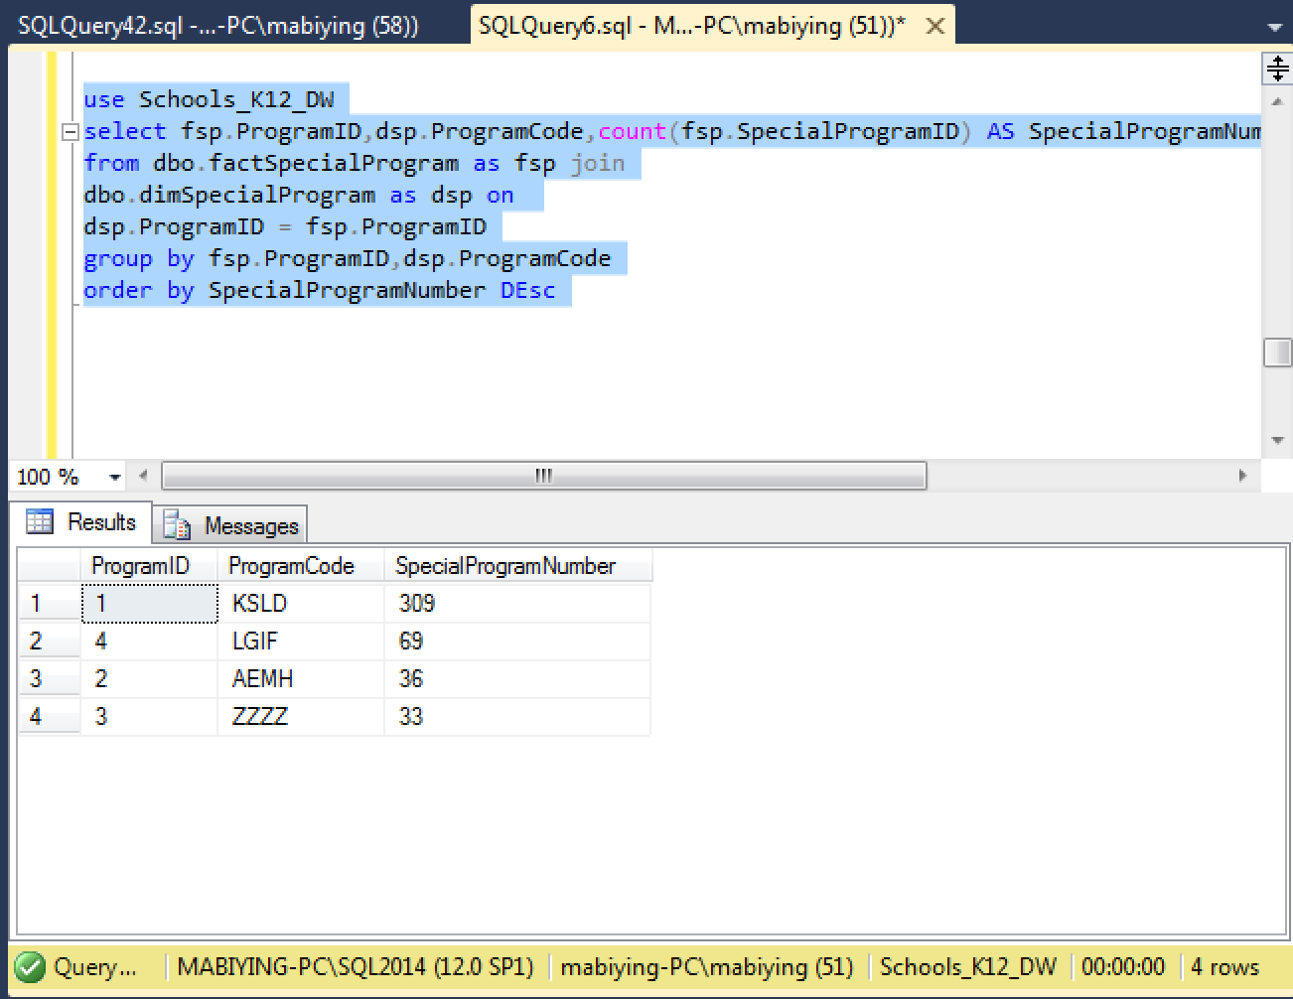

4.3 Special Programs from parents perspective:

For each grade, How many student attend special programs in year of 2010

use Schools_K12_DW

select ds.Grade,count(fsp.StudentID) AS StudentNumber

from dbo.factSpecialProgram as fsp join

dbo.dimStudent as ds on

ds.StudentID= fsp.StudentID

where year(fsp.EntryDate) = '2010'

group by ds.Grade

